Claire Hanna
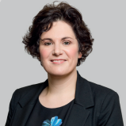

Claire has been MLA for South Belfast since July 2015, having previously served as a Belfast Councillor, first elected in 2011.

She is the SDLP spokesperson on Brexit and Finance; and deputy chair of the Assembly Finance Committee, having previously served on the Public Accounts and Environment Committees.

As a City Councillor Claire brought the motion that led to Belfast becoming the first Living Wage council in Ireland, paying a fair wage to all employees. She has also campaigned for City Deals for Northern Ireland and before the Assembly was dissolved this year, had been working on a private member’s bill that would offer legal protection for mothers and babies breastfeeding in public places.

Claire is a graduate of the Open University and has completed a Masters in Law at Queen's University Belfast. She is married and has three small children.

